PYTHON PROGRAMMING

(PRACTICAL LAB)

School of Computer Applications
Department of Computer Applications

Submitted By
Student Name | Hansika
Roll No | 24/SCA/BCA(AI&ML)/022
Programme | BCA (AI&ML)
Semester | ^{3rd} Semester
Section/Group | III C
Department | Computer Applications
Batch | 2024-2027
Submitted To
Faculty Name | Mrs. Sakshi

Q1. Write a Python program to calculate number of days between two dates.
Sample dates: (2014, 7, 2), (2014, 7, 11)
Expected output: 9 days
Understand (Basic operation) / L2
# Answer 1
from datetime import date

date1 = date(2014, 7, 2)
date2 = date(2014, 7, 11)

days = date2 - date1
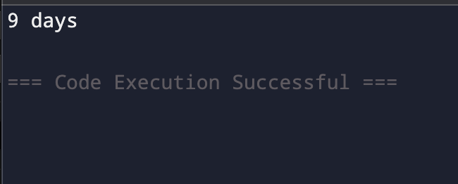
print(days.days, "days")

Q2. Write a Python program that accepts an integer (n) and computes the value of n + nn + nnn.
Understand (Pattern recognition) / L2
# Answer 2
n = int(input("Enter an integer: "))
n1 = int("%d" % n)
n2 = int("%d%d" % (n, n))
n3 = int("%d%d%d" % (n, n, n))

print("Result:", n1 + n2 + n3)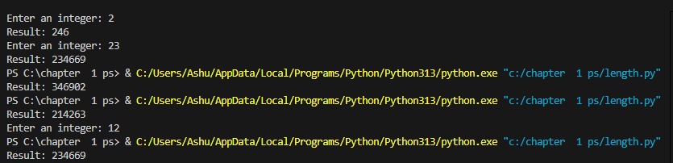

Q3. Ask the user for a number. Depending on whether the number is even or odd, print out an appropriate message.
Apply (Control structure & logic) / L3
# Answer 3
num = int(input("Enter a number: "))

if num % 2 == 0:
print("The number is even.")
else:
print("The number is odd.”)

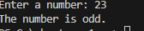

Q4. Write a Python program which accepts a sequence of comma-separated numbers and generate a list and a tuple.
Apply (Iterative algorithm) / L3
# Answer 4
values = input("Enter comma-separated numbers: ")

list_values = values.split(",")
tuple_values = tuple(list_values)

print("List:", list_values)
print("Tuple:", tuple_values)
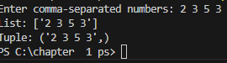

Q5. Write a Python program to calculate the sum of three given numbers. If the values are equal, return thrice of their sum.
Apply (Loop and formula use) / L3
# Answer 5
x = int(input("Enter first number: “))
y = int(input("Enter second number: “))
z = int(input("Enter third number: “))
sum = x + y + z
if x == y == z:
sum = sum * 3
print("Result:", sum)

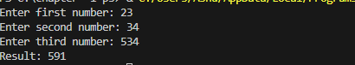

Q6. Write a Python program to test whether a passed letter is a vowel or not Apply (String manipulation) / L3
# Answer 6
ch = input("Enter a letter: ")

if ch in 'aeiouAEIOU':
print(ch, "is a vowel.")
else:
print(ch, "is not a vowel.”)

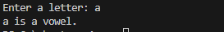

Q7. Take a list a = [1,1,2,3,5,8,13,21,34,55,89] and print all elements less than 5.
Extras:
Make a new list with these elements.
Ask user for a number and return elements smaller than that number.
Apply (Array manipulation) / L3

# Answer 7
a = [1, 1, 2, 3, 5, 8, 13, 21, 34, 55, 89]

print("Numbers less than 5:")
for i in a:
if i < 5:
print(i)

new_list = [i for i in a if i < 5]
print("New list:", new_list)

num = int(input("Enter a number: "))
user_list = [i for i in a if i < num]
print("Numbers smaller than", num, ":", user_list)

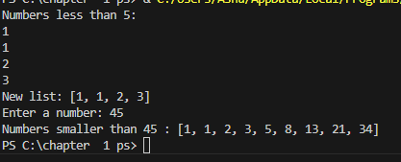

Q8. Create a program that asks the user for a number and prints all its divisors.
Apply (Modulo Logic) / L3
# Answer 8
num = int(input("Enter a number: "))

print("The divisors of", num, "are:")
for i in range(1, num + 1):
if num % i == 0:
print(i)
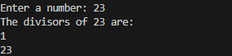

Q9. Take two lists and return a list containing only the common elements (without duplicates).
Apply (List Operations) / L3
# Answer 9
a = [1, 1, 2, 3, 5, 8, 13, 21, 34, 55, 89]
b = [1, 2, 3, 4, 5, 6, 7, 8, 9, 10, 11, 12, 13]
common = []
for i in a:
if i in b and i not in common:
common.append(i)
print("Common elements:", common)
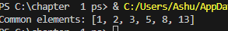

Q10. Ask the user for a string and print whether it is a palindrome or not.
Apply (Slicing) / L3
# Answer 10
text = input("Enter a string: ")
if text == text[::-1]:
print("It is a palindrome.")
else:
print("It is not a palindrome.”)

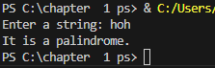

11.Even elements from list
Input
a = [1,4,9,16,25,36,49,64,81,100]
even_list = [x for x in a if x % 2 == 0]
print(even_list) 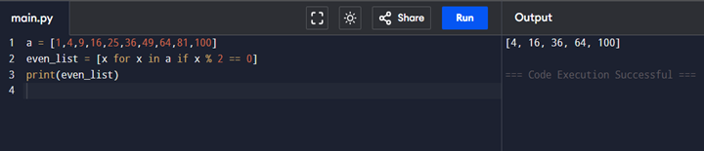

12.Random guess game
import random
num = random.randint(1,9)
guess = int(input('Guess number: '))
if guess < num:
print('Too low')
elif guess > num:
print('Too high')
else:
print(‘Correct!')
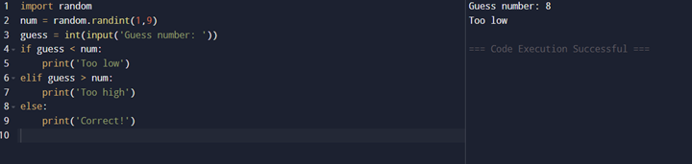

13. Prime number check

n = int(input('Enter number: '))
if n > 1:
for i in range(2,n):
if n % i == 0:
print('Not prime')
break
else:
print('Prime')
else:
print('Not prime')
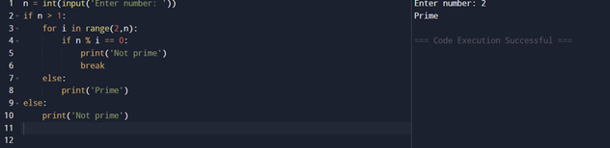

14.Remove duplicates
def remove_dup(lst):
return list(set(lst))
print(remove_dup([1,2,2,3,4,4,5]))

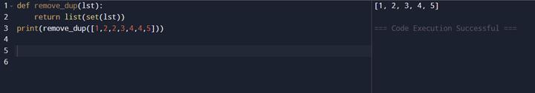

15. Check number in ordered list

def check(lst, num):
return num in lst
print(check([1,2,3,4,5], 3))

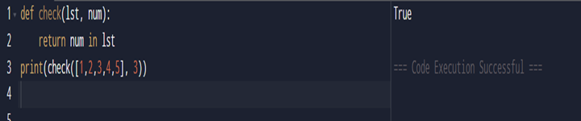

16. Largest of three numbers

def largest(a,b,c):
if a >= b and a >= c:
return a
elif b >= a and b >= c:
return b
else:
return c
print(largest(10,25,3))

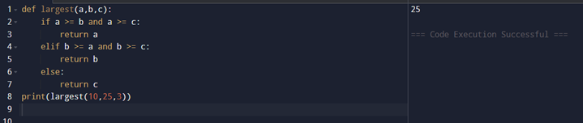

17.Python program to perform read and write operations on a file.

with open("sample.txt", "w") as file:
file.write("Hello, this is a sample file.\n")
file.write("This file demonstrates read and write operations in Python.")

with open("sample.txt", "r") as file:
content = file.read()
print("File Content:\n", content)

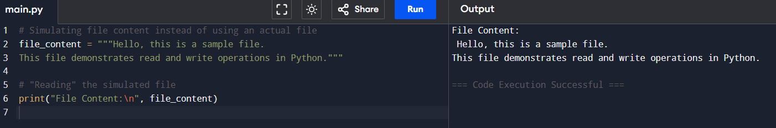

18.Copy Contents of One File to Another

source_file = "sample.txt"
destination_file = "copy_sample.txt"
with open(source_file, "r") as src:
data = src.read()
with open(destination_file, "w") as dest:
dest.write(data)
print(f"Contents of '{source_file}' copied to ‘{destination_file}'.")

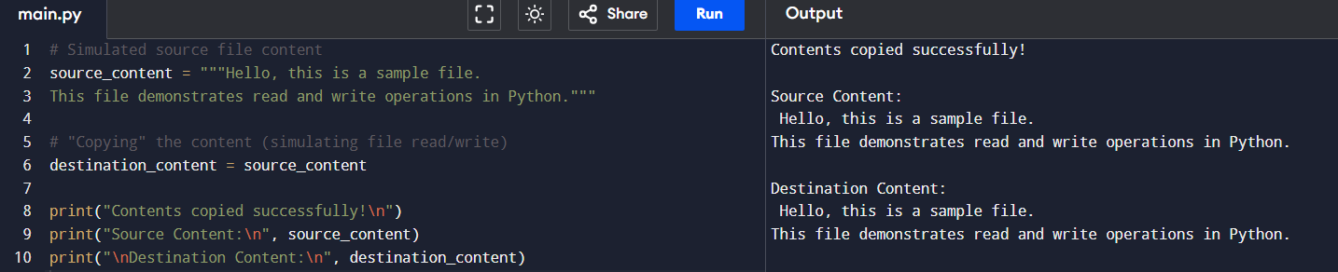

19.Count Frequency of Characters in a File

char_frequency = {}
with open("sample.txt", "r") as file:
text = file.read()
for char in text:
if char != "\n": # Ignore newline characters
char_frequency[char] = char_frequency.get(char, 0) + 1
print("Character Frequency:")
for char, freq in char_frequency.items():
print(f"'{char}': {freq}”)
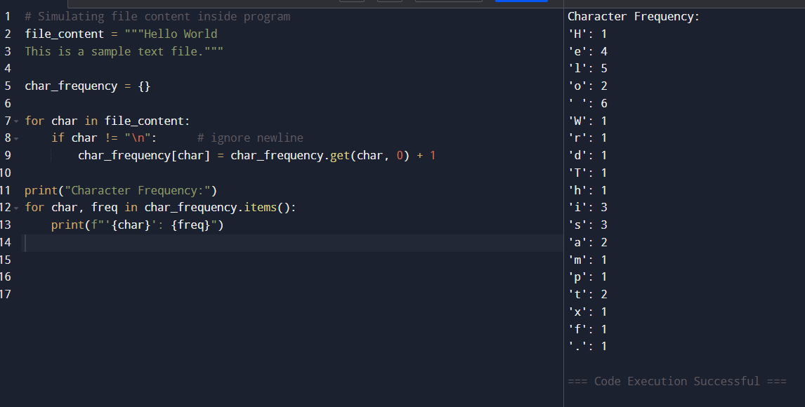
20.Python program to print each line of a file in reverse order.
file_content = """Hello world
Python is fun
This is a test"""
lines = file_content.split("\n")
print("Reversed Lines:")
for line in lines:
print(line[::-1])
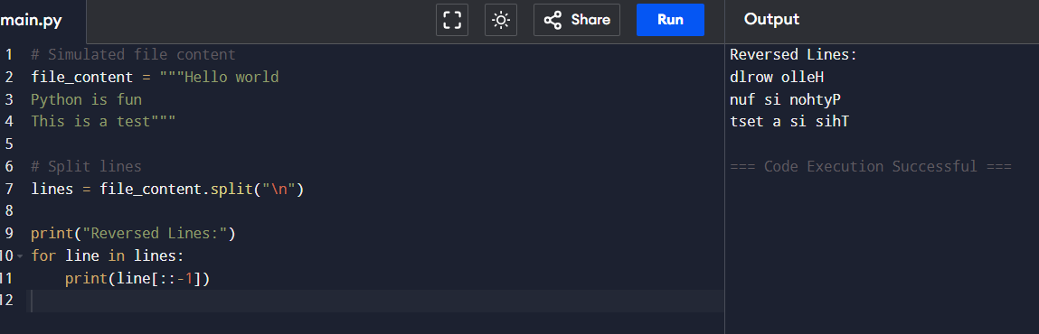

21.Python program to compute the number of characters, words and lines in a file.
file_content = """Hello world Python is fun This is a test"""
chars = len(file_content.replace("\n", "")) # ignore newlines words = len(file_content.split()) lines = len(file_content.split("\n"))
print("Characters:", chars) print("Words:", words) print("Lines:", lines)
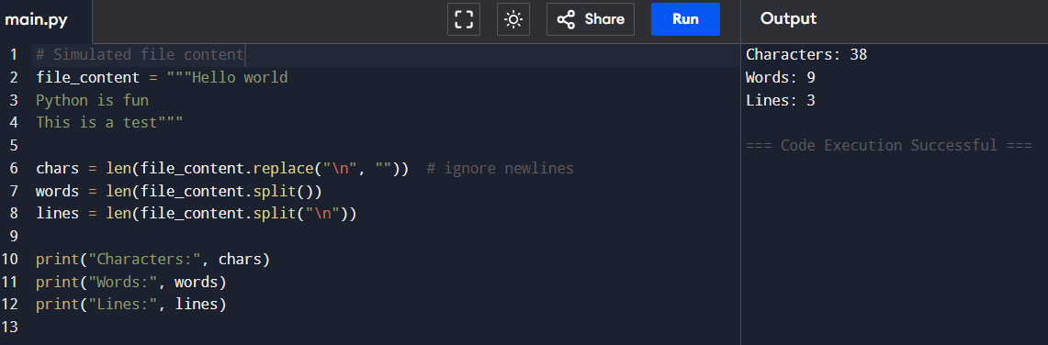

22.Write a program that prompts the user to enter his name. The program then greets the person with his name. But if
the person’s name is ‘Rahul’ and exception is thrown and he is asked to quit the program.

class RahulException(Exception):
pass

name = input("Enter your name: ")

try:
if name.lower() == "rahul":
raise RahulException("Access denied for Rahul! Quit the program.")
else:
print("Hello,", name)
except RahulException as e:
print(e)

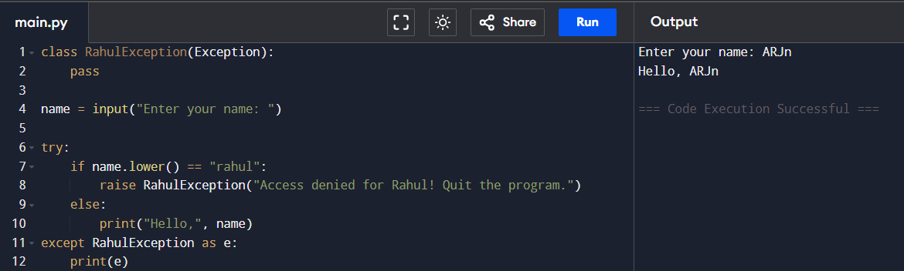

23.Write a program that accepts date of birth along with the
other personal details of a person. Throw an exception if an invalid date is entered

from datetime import datetime

try:
name = input("Enter your name: ")
dob = input("Enter DOB (DD-MM-YYYY): ")

# Validate date format
datetime.strptime(dob, "%d-%m-%Y")

print("Details saved successfully!")
print("Name:", name)
print("DOB:", dob)

except ValueError:
print("Invalid date! Please enter DOB in DD-MM-YYYY format.")

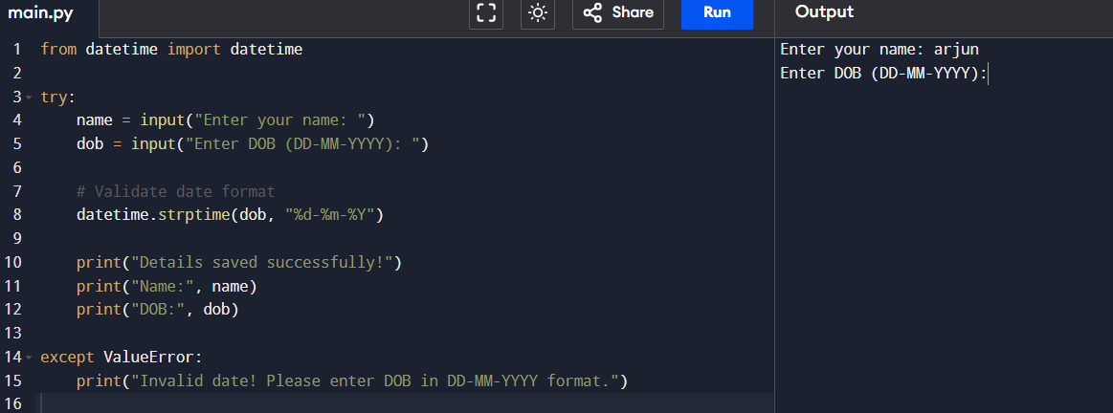

24.Write a Regular Expression to represent all 10 digit mobile numbers. Rules: 1. Every number should contains exactly 10 digits. 2. The first digit should be 7 or 8 or 9 Write a Python Program to check whether the given number is valid mobile number or not?

import re

number = input("Enter mobile number: ")

pattern = r"^[789]\d{9}$"

if re.match(pattern, number):
print("Valid mobile number")
else:
print("Invalid mobile number”)

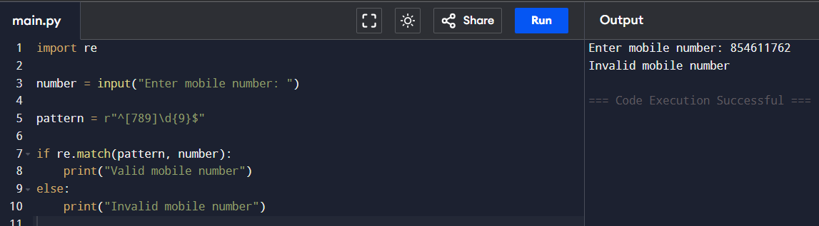

25.A spell checker can be a helpful tool for people who struggle to spell words correctly. In this exercise, you will write a program that reads a file and displays all of the words in it that are misspelled. Misspelled words will be identified by checking each word in the file against a list of known words. Any words in the user’s file that do not appear in the list of known words will be reported as spelling mistakes. The user will provide the name of the file to check for spelling mistakes as a command line parameter. Your program should display an appropriate error message if the command line parameter is missing. An error message should also be displayed if your program is unable to open the user’s file. Words followed by a comma, period or other punctuation mark are not reported as spelling mistakes. Ignore the capitalization of the words when checking their spelling.

known_words = {"hello", "world", "python", "is", "fun", "this", "a", "test", “file"}
user_file_content = """Helo world.
Python is fn.
This file is amazng”""
import string
clean_text = user_file_content.translate(str.maketrans("", "", string.punctuation))
misspelled = []
for word in clean_text.split():
if word.lower() not in known_words:
misspelled.append(word)
print("Misspelled Words:", misspelled) 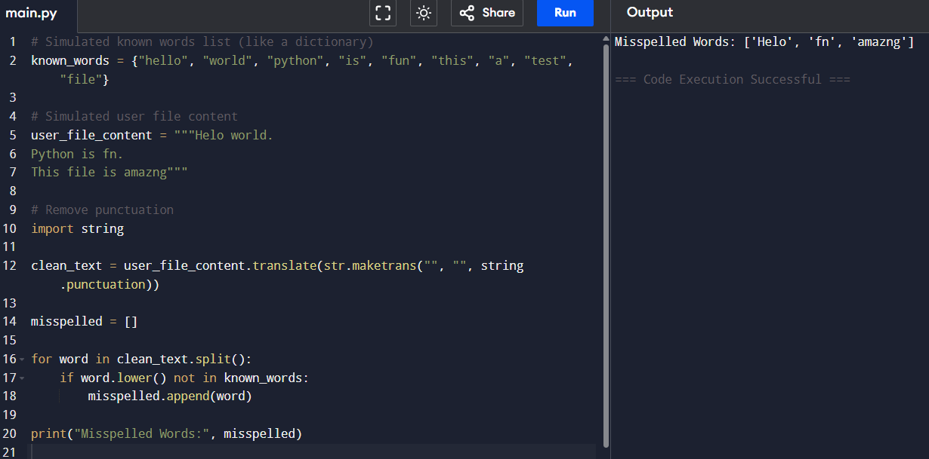

26.A fitness coach wants to analyze the BMI of a group of people to assess their health status. The data includes the name, age, weight (kg), and height (m) of each person. The coach wants:
To calculate BMI for each person.
To categorize each person based on their BMI.
To get a summary of how many people
fall into each category.

def calculate_bmi(weight, height):
return weight / (height ** 2)

def categorize_bmi(bmi):
if bmi < 18.5:
return "Underweight"
elif 18.5 <= bmi < 25:
return "Normal weight"
elif 25 <= bmi < 30:
return "Overweight"
else:
return "Obese"
people = [
("Arjun", 20, 60, 1.70),
("Riya", 22, 48, 1.58),
("Rahul", 25, 85, 1.75),
("Neha", 30, 72, 1.65),
("Vivek", 28, 95, 1.80)
]
summary = {
"Underweight": 0,
"Normal weight": 0,
"Overweight": 0,
"Obese": 0
}
print("BMI Report:\n")
for name, age, weight, height in people:
bmi = calculate_bmi(weight, height)
category = categorize_bmi(bmi)
print(f"Name: {name}")
print(f"Age: {age}")
print(f"Weight: {weight} kg")
print(f"Height: {height} m")
print(f"BMI: {bmi:.2f}")
print(f"Category: {category}\n")
# Update summary
summary[category] += 1
print("Summary of BMI Categories:")
for category, count in summary.items():
print(f"{category}: {count} people")
